worksheet 34: BuildHeap and Heap Sort Name:

**Worksheet 34: BuildHeap and Heap Sort**

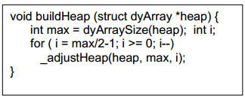**In preparation**: If you have not done so already, you should complete Worksheet 33 to learn more about the heap data structure.

In some applications it is useful to initialize a Heap with an existing vector of values. The values are not assumed to be organized into a heap, and so a routine named buildHeap is invoked for this purpose.

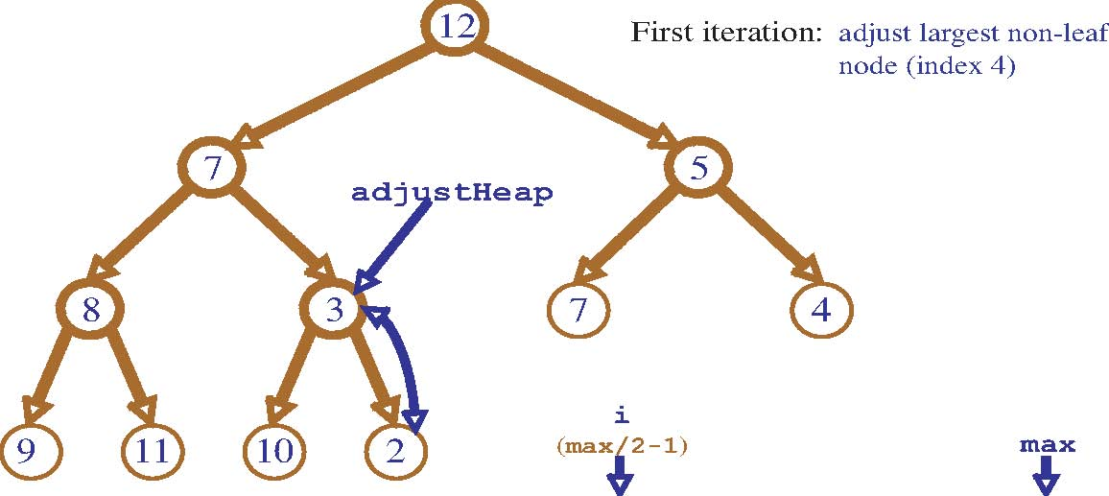

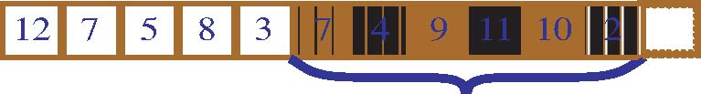

All values indexed after max/2 are leaves, and are therefore already a heap. The first value that could potentially not be a heap is found at max/2. Walking backwards from this value until the root is reached eventually makes all nodes into a heap.

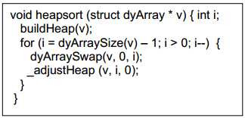The heap data structure provides an elegant technique for sorting a vector. First form the vector into a heap. To sort the vector, the top of the heap (the smallest element) is swapped with the last element, and the size of the heap is reduced by 1 and readjusted. Repeat until all elements have been processed.

worksheet 34: BuildHeap and Heap Sort Name:

Simulate execution of the Heap sort algorithm on the following values:

9 3 2 4 5 7 8 6 1 0

First make the values into a heap (the graphical representation is probably easier to work with than the vector form). Then repeatedly remove the smallest value, and rebuild the heap.

9

3

2

4

5

7

8

6

1

0

9

3

2

4

5

7

8

6

1

0

Initial State:

0

1

2

4

3

7

8

6

9

5

Then:

Start Sorting:

1

3

2

4

5

7

8

6

9

0

2

3

7

4

5

9

8

6

1

0

2

3

7

4

5

9

8

6

1

0

9

8

7

6

5

4

3

2

1

0

6

8

7

9

5

4

3

2

1

0

5

6

7

9

8

4

3

2

1

0

4

5

7

6

8

9

3

2

1

0

3

4

7

6

5

9

8

2

1

0